Lab Manual



Course: BI-402

Bioinformatics Software Development

Term: Fall 2020, Class: BSBI-2017

Submitted By:

TALHA NAEEM 2017-BI-005

(Name) (Roll. No.)

Submitted To:

**Ms. Mehwish Mehmood**

**Department Of Bioinformatics**

**Sir Syed University Of Engineering and Technology**

**University Road Karachi - 75300**

<http://www.ssuet.edu.pk>

Table of content

|  |  |  |  |  |
| --- | --- | --- | --- | --- |
| S.no | Lab No | Task | Sig. | Remarks |
| 1 | 1 | **Creating Gantt Chart & PERT Chart Using MS Project** |  |  |
| 2 | 2 | **Introduction to UML (Unified Modeling Language) Diagram and Modeling use case diagram using visual paradigm** |  |  |
| 3 | 3 | **Creating Sequence Diagram using Visual Paradigm Software** |  |  |
| 4 | 4 | **Web Development Framework Using**  **“Dreamweaver CS 5”** |  |  |
| 5 | 5 | **Introduction to CSS** |  |  |
| 6 | 6 | **More About CSS and Designing a Website** |  |  |
| 7 | 7 | **Introduction of Java Script and Form Validation with Java Script** |  |  |
| 8 | 8 | **Introduction of Server Side Scripting** |  |  |
| 9 | 9 | **Server Site Scripting on MY SQL and Database (Authentication)** |  |  |
| **10** | **10** | **Web Development – View Record** |  |  |
|  |  |  |  |  |
|  |  |  |  |  |

**LAB 10**

**Web Development – View Record**

**Exercise:**

1. Create a table of student with these columns stdid, name, fathername, class, roll# into a database using MySQL command prompt and phpMyAdmin and insert at least three rows in the table by phpadmin tools and view these record on browser after login attempt.

**LOGIN ID SOURCE CODE**

<!doctype html>

<html>

<head>

<meta charset="utf-8">

<link type="text/css" href="about.css" rel="stylesheet" />

<link rel="stylesheet" href="https://stackpath.bootstrapcdn.com/font-awesome/4.7.0/css/font-awesome.min.css">

</head>

<body>

<center>

<div class="login_box">

<h1> LOGIN</h1>

<form action="validation.php" method="post">

<div class="textbox">

<i class="fa fa-user" aria-hidden="true"></i>

<input type="text" placeholder="Enter User ID" name="user" value=""><br><br>

</div>

<div class="textbox">

<i class="fa fa-unlock-alt" aria-hidden="true"></i>

<input type="password" placeholder="Enter Password" name="pass" value=""><br><br>

</div>

<input class ="btn" type="submit" name="submitbtn" value= "Sign in">

</form><center>

</div>

</body>

**OUTPUT**



**LOGIN TABLE**

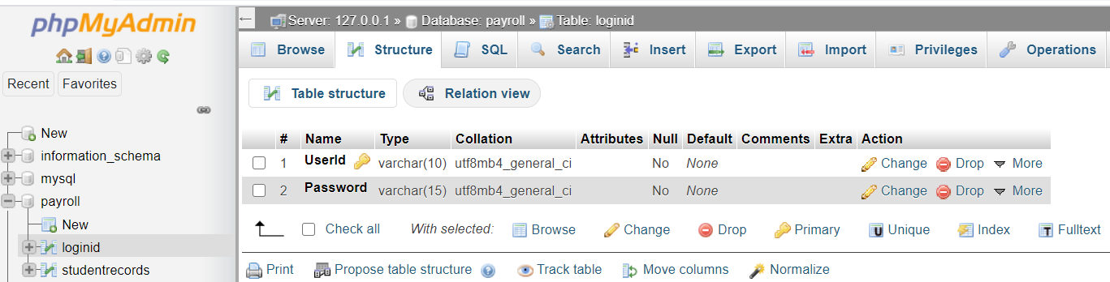

**LOGIN TABLE VALUES**

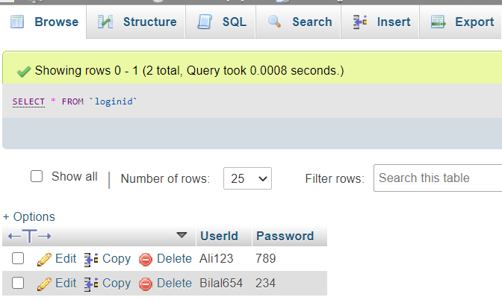

**OUTPUT IN PHP**

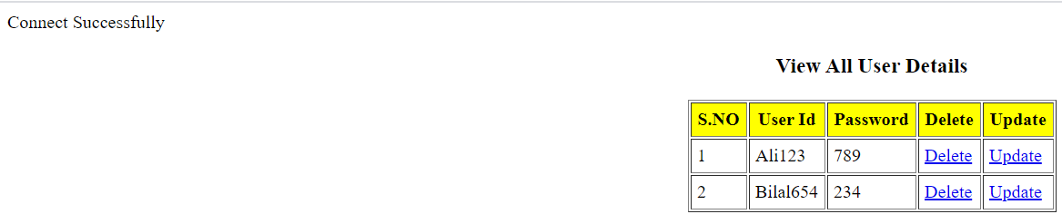

**STUDENT RECORDS TABLE**

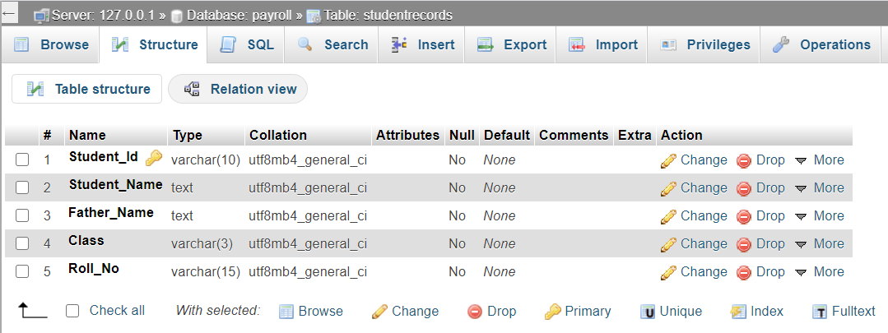

**STUDENT RECORDS TABLE VALUES**

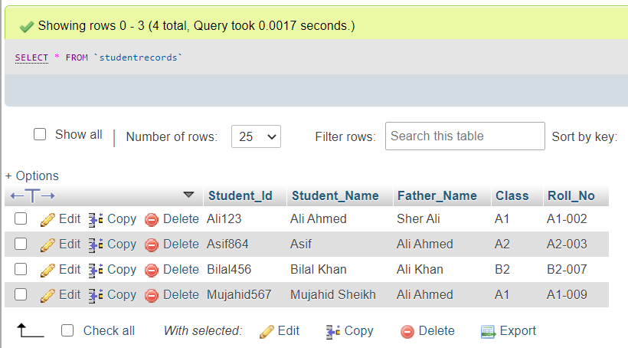

**WELCOME SOURCE CODE**

/<!doctype html>

<html>

<head>

<meta charset="utf-8">

<title>Untitled Document</title>

</head>

<body>

<?php

session_start();

echo "Welcome User : ";

echo $_SESSION['user'];

echo "<br>";

echo "<br>";

echo "Manage User Menu";

echo "<br>";

echo "================";

echo "<br>";

echo "<br>";

?>

<a href="studentrecords.php">1. View students reports</a>

<br>

<a href="logindetailveiw.php">2. View Student Login</a>

<br> <a href="search.php">3. Search reports</a>

</body>

</html>

**OUTPUT**

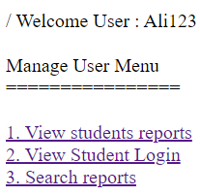

**STUDENT RECORDS SOURCE CODE**

<?php

include("coni.php");

?>

<center style="color: green;">

<?php

if(isset($_GET['success'])){

$success = $_GET['success'];

echo $success;

}

?>

</center>

<table border="1" cellpadding="5" align="center">

<caption><h3>View Student Records</h3></caption>

<tr style="background-color: yellow;">

<th>S.NO</th>

<th>Student ID</th>

<th>Name</th>

<th>Father Name</th>

<th>Class</th>

<th>Roll No</th>

<th>Delete</th>

<th>Update</th>

</tr>

<?php

$query = "SELECT * FROM studentrecords";

$result = mysqli_query($con, $query);

$i=0;

while($row = mysqli_fetch_array($result))

{

$id = ++$i;

$stdid = $row['Student_Id'];

$name = $row['Student_Name'];

$fname = $row['Father_Name'];

$class = $row['Class'];

$rollno = $row['Roll_No'];

echo '<tr> ';

echo '<td>'. $id.'</td>';

echo '<td>'. $stdid.'</td>';

echo '<td>'. $name.'</td>';

echo '<td>'. $fname.'</td>';

echo '<td>'. $class.'</td>';

echo '<td>'. $rollno.'</td>';

echo '<td><a href="#">'. "Delete".'</td>';

echo '<td><a href="#">'. "Update".'</td>';

} ?>

</table>

**OUTPUT IN PHP**

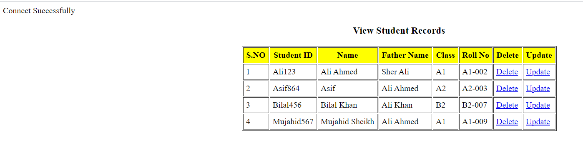

**SEARCH SOURCE CODE**

<!doctype html>

<html>

<head>

<meta charset="utf-8">

<title>Searching</title>

</head>

<body>

<?php

include("coni.php");

?>

<center style="color: green;">

<?php

if(isset($_GET['success'])){

$success = $_GET['success'];

echo $success;

}

?>

</center>

<table border="1" cellpadding="5" align="center">

<caption><h3>Seacrh the Student Records</h3></caption>

<tr style="background-color: yellow;">

<th>S.NO</th>

<th>Student ID</th>

<th>Name</th>

<th>Father Name</th>

<th>Class</th>

<th>Roll No</th>

<th>Delete</th>

<th>Update</th>

</tr>

<?php

$query = "SELECT * FROM studentrecords where Father_Name = 'Ali Ahmed'";

$result = mysqli_query($con, $query);

$i=0;

while($row = mysqli_fetch_array($result))

{

$id = ++$i;

$stdid = $row['Student_Id'];

$name = $row['Student_Name'];

$fname = $row['Father_Name'];

$class = $row['Class'];

$rollno = $row['Roll_No'];

echo '<tr> ';

echo '<td>'. $id.'</td>';

echo '<td>'. $stdid.'</td>';

echo '<td>'. $name.'</td>';

echo '<td>'. $fname.'</td>';

echo '<td>'. $class.'</td>';

echo '<td>'. $rollno.'</td>';

echo '<td><a href="#">'. "Delete".'</td>';

echo '<td><a href="#">'. "Update".'</td>';

} ?>

</table>

</body>

</html>

**SEARCH FATHER NAME IN SQL**

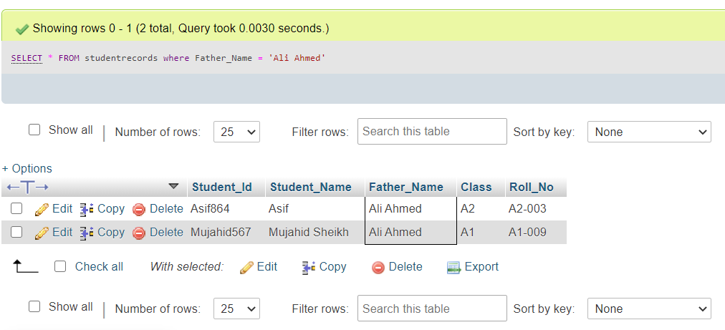

**OUTPUT IN PHP**

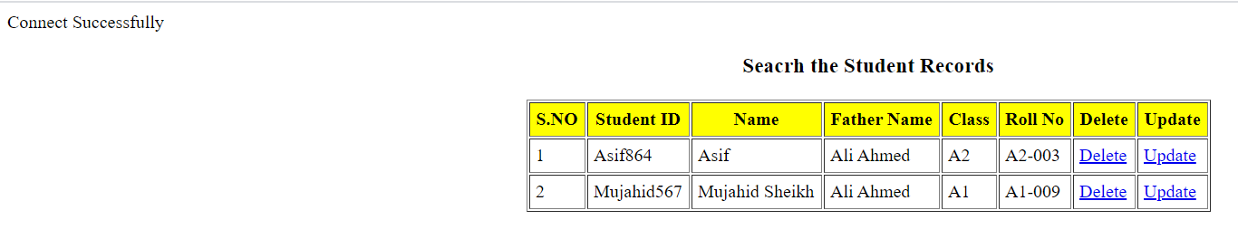

**VALIDATION SOURCE CODE**

<?php

include("conn.php");

session_start();

if(isset($_POST['success'])){

$success = $_POST['success'];

echo $success;

}

$myusername = $_POST['name'];

$mypassword = $_POST['pass'];

$_SESSION['usern']= $myusername;

$query = "select * from login where userid='$myusername' and password='$mypassword'";

$result = mysqli_query($con, $query);

$count=mysqli_num_rows($result);

echo "count=".$count;

if($count==1)

{

header("Location: welcome.php");

echo "Login successfully";

}

else {

echo "Your Login Name or Password is invalid";}

?>